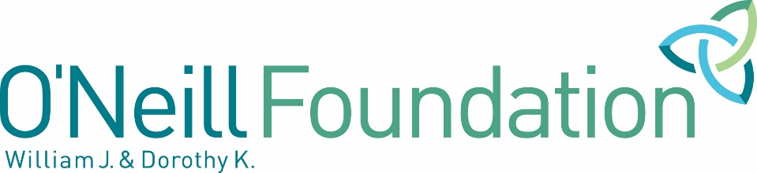

Responsive Grantmaking Program
Activity Plan – General Operating Support

If selected for funding, grantees will use this Activity Plan to track activities and report progress in meeting grant objectives.

Organization
Project Title
Grant Term

Please list up to three primary objectives for this grant.

Mission | (Insert your organization’s Mission Statement)
Strategic Plan Objective 1  Anticipated Results | (Insert a primary objective from your current Strategic Plan that you will undertake during the grant period to advance your mission.)  (Insert anticipated results for participants, the community and/or your organization: What changes for families do you expect as a result of the objective and activities?)
Activities and Timeline  List key activities to implement the objective. Who will engage in what action? How often will they occur, and over what period of time? Include the dates and/or months when you anticipate each activity will be completed. | Target Population  Include the number of individuals or families that will benefit, where applicable | Progress  Indicate how will you track and confirm progress. What information will be collected and how will it be collected? Examples: survey, interview, observation, record or document review
1. a (insert text)  1. b (insert text) | 1. a (insert text)  1. b (insert text) | 1. a (insert text)  1. b (insert text)
Strategic Plan Objective 2  Anticipated Results | (Insert a primary objective from your current Strategic Plan that you will undertake during the grant period to advance your mission.)  (Insert anticipated results for participants, the community and/or your organization: What changes for families do you expect as a result of the objective and activities?)
Activities and Timeline  List key activities to implement the objective. Who will engage in what action? How often will they occur, and over what period of time? Include the dates and/or months when you anticipate each activity will be completed. | Target Population  Include the number of individuals or families that will benefit, where applicable | Progress  Indicate how will you track and confirm progress. What information will be collected and how will it be collected? Examples: survey, interview, observation, record or document review
2. a (insert text)  2. b (insert text) | 2. a (insert text)  2. b (insert text) | 2. a (insert text)  2. b (insert text)

